Chapter 5: Physical and chemical change

5.1 Physical change is a change in shape or appearance

Literacy support answers (pages 80–81)

Physical changes

1 What is a physical change?

A change that is reversible is a physical change.

2 Give an example of a physical change and explain why it is a physical change.

The melting of ice into water – it is a physical change as water can be frozen back into ice.

3 What happens to the molecules in water when they change state from a liquid to a gas?

The molecules move further apart and gain more kinetic energy.

4 Give four examples of physical changes in your home:

Answers will vary.

• Boiling of water to cook food – can be reversed back into a liquid via condensation

• Melting of ice in your drink on a hot day – this is reversible as it can be re-frozen

• Condensation on windows on a cold morning caused by gases being cooled into liquids

• Water frozen into ice cubes in the freezer on a hot day

5 Draw a line to match each of the words on the left with its corresponding meaning, on the right.

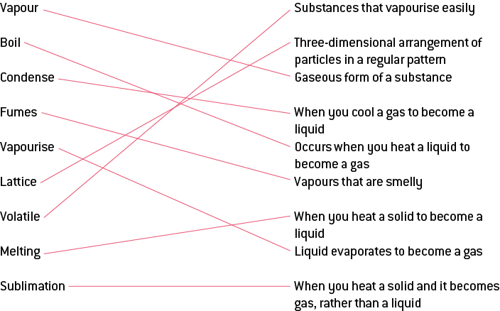

6 What happens to the molecules in water when they change state from a gas to a liquid?

The molecules move closer together and lose kinetic energy.

7 Explain why boiling water is a physical change.

The boiling of water into steam can be reversed as steam can be condensed into water, so it is a physical change.

8 Label the following diagram with the correct terminology to illustrate a change in state of water:

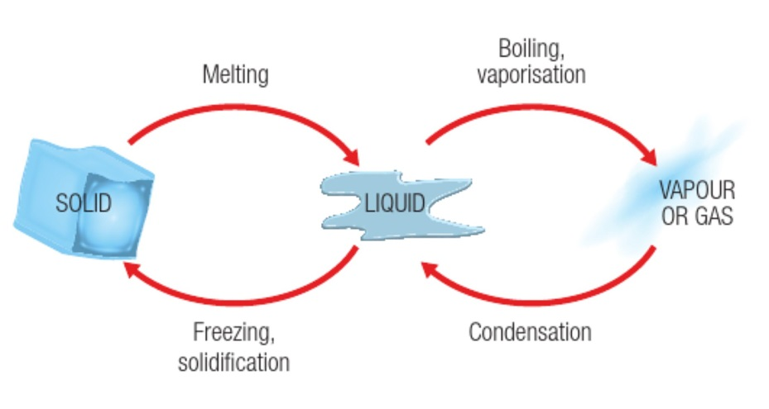

Word detective

9 True or false

Read each of the following statements and indicate whether it is true or false.

a One example of a volatile substance is cooking oil.

F

b Physical changes are not reversible.

F

c No new substances are created a physical change.

T

d Condensation is when a solid is heated and changes state to become a liquid.

F

e Applying a force to a substance can cause a physical change.

T

f Water molecules vibrate at a much slower rate when heat energy is added.

F

g Volatile substances vaporise easily.

T

h Gases normally change state to become liquid by cooling.

T

5.2 Chemical change produces new substances

Literacy support answers (pages 82–83)

Chemical changes

1 When a chemical change occurs the original substances are rearranged to form:

New substances

2 Use the following diagram to explain the difference between a chemical and physical change.

The purple balls represent: a physical change

The purple and pink balls represent: a chemical change

3 What are the four changes that you would look for to know that a chemical change has occurred?

Gas is produced

Non-reversible colour change

Light or heat is absorbed

A precipitate is formed that does not go away

4 When chocolate is melted it is a physical change because the way it looks changes.

5 When chocolate is burnt it is a chemical change because it can’t be reversed.

6 When you bake a cake, does a physical or chemical change take place?

Chemical

7 Are the following pictures examples of chemical or physical changes?

|  |  |  |  |
| --- | --- | --- | --- |
| physical | chemical | chemical | physical |
| chemical | chemical | physical | chemical |

Word detective

8 Matching meaning

Read the words below and match them to the correct pictures. Write whether it is a chemical or physical change in the spaces provided.

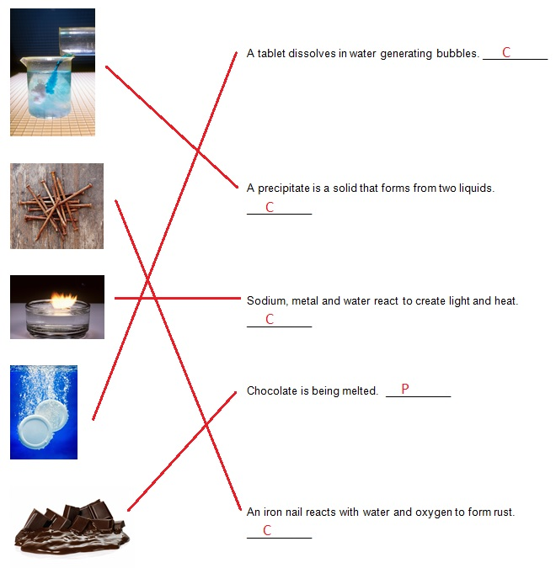

5.3 Chemical reactions can break bonds and re-form new bonds

Literacy support answers (pages 84–85)

Chemical reactions

1 Reactants are chemicals that react when placed together.

What is a chemical product?

The substances that are produced or formed are chemical products.

2 The diagram below shows a worded chemical reaction. Write a worded chemical equation for the following chemical reactions:

a Oxygen and hydrogen react to form water.

hydrogen + oxygen → water

b Iron and oxygen will form iron oxide.

iron + oxygen → iron oxide

c Water and carbon dioxide react in the leaves of plants to form glucose (a sugar) and oxygen.

water + carbon dioxide → glucose + oxygen

c Petrol, in a car, will burn in the presence of oxygen to form carbon dioxide and water.

petrol + oxygen → carbon dioxide + water

d Water and carbon dioxide react in the leaves of plants to form glucose (a sugar) and oxygen.

water + carbon dioxide → glucose + oxygen

reactants → products

e Petrol, in a car, will burn in the presence of oxygen to form carbon dioxide and water.

petrol + oxygen → carbon dioxide + water

reactants → products

3 What is a combustion reaction?

A reaction with oxygen to produce energy

4 Write a worded equation for the combustion of magnesium.

magnesium + oxygen → magnesium oxide (+ energy as light)

5 Fill in the flow diagram by placing the sentences below in the correct order to describe a combustion reaction between magnesium and oxygen:

Magnesium interacts with oxygen in the air. Start with a magnesium ribbon. A white powder, magnesium oxide is formed. Magnesium ribbon burns.

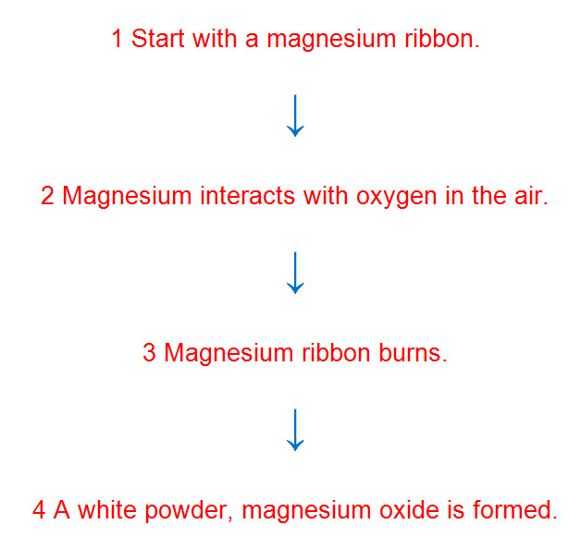

6 The products of the combustion of hydrocarbons are carbon dioxide and water. Write worded equations for:

a The combustion of ethene:

ethene + oxygen → carbon dioxide + water

reactants → products

b The combustion of octane:

octane + oxygen → carbon dioxide + water

reactants → products

Word detective

7 Mumbo jumbo

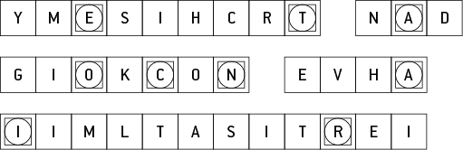

Message: Chemistry and cooking have similarities.

Secret word: reaction

5.4 Heat can speed up a reaction

Literacy support answers (pages 86–87)

The effect of heat on the speed of reactions

1 What factors affect the rate of a reaction?

Particle size

Temperature

Concentration

Catalyst

2 How does particle size effect the rate of a chemical reaction? Finish the sentence:

The smaller the particle size, the faster the rate of the reaction.

3 Which of the following diagrams will have a faster rate of reaction (a) or (b)?

Diagram a, as smaller particles with a larger surface area will have a faster rate of reaction.

4 What must happen in order for chemicals to react? Finish this sentence:

The more the collisions happen between the particles, the more likely they are to react.

5 How does temperature increase the rate of a reaction?

When heat energy is added to the substance the particles move quicker and collide more frequently.

6 What type of energy does temperature give to particles?

Kinetic energy

7 The higher the concentration the more particles it has. How would this affect the amount of collisions?

The higher the concentration the more particles are able to collide with particles from another substance.

8 How does the rate of collisions affect the rate of a reaction?

The more collisions, the more likely a reaction is.

9 Which of the following diagrams will have a faster rate of reaction, (a) or (b)? Explain why.

Diagram b, as it is more concentrated (more particles) which will collide more often.

10 What is a catalyst?

It is a substance that increases the rate of a reaction without becoming used up by it.

11 Why do we need enzymes in our bodies?

To help to digest food and perform other functions.

Word detective

12 True or false

Read the statement and circle whether it is true or false.

a The concentration of a substance affects the reaction rate.

T

b The bigger the particles, the faster the reaction.

F

c The lower the temperature the faster the reaction.

F

d Collision theory states that the more collisions, the more likely there’s a reaction.

T

e As coffee cools the kinetic energy in its particles increase.

F

f Enzymes are catalysts.

T

g Vitamin C is a catalyst.

F

5.5 Science as a human endeavour: Many substances exist because of the work of scientists

Literacy support answers (pages 88–89)

Chemical substances

1 What do pharmacists study?

Chemistry

2 What field of study do they specialise in?

Pharmacology – the study of medicines

3 What is the chemist who works in a pharmacy called?

Pharmacist

4 Fill in the gaps in the flow diagram on crude oil by using the sentences below.

The low value parts are converted into high value products. It is carried in pipelines or tankers to refineries. Oil is pumped from the ground. Oil is separated into its components.

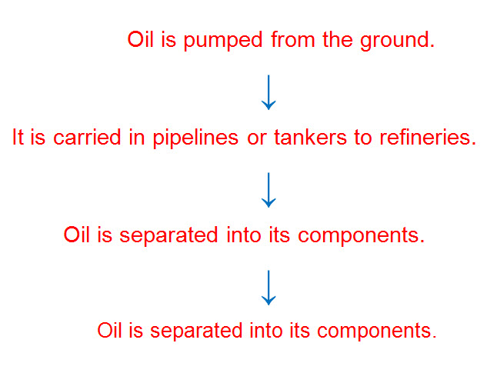

5 What high-value materials is crude oil converted into?

• Petrol

• Diesel

• Plastics

6 What can plastics be used for?

• Freezer bags

• CD cases

• Shoes

• Furniture

• Clothing

7 What was the first documented case of glue used for and who used it?

King Nebuchadnezzar used bitumen to hold building stones together.

8 Which natural glues were used for gluing paper and wood?

• Plant gum

• Egg whites

• Animal products

9 What was the first dye obtained from?

Murex Whelk shells – a type of snail

10 What is an advantage of modern inks over earlier ones?

Modern inks do not fade and are therefore able to last longer.

Word detective

11 Matching meaning

Draw a line to match the type of chemist (on the left) with the job they do (on the right).

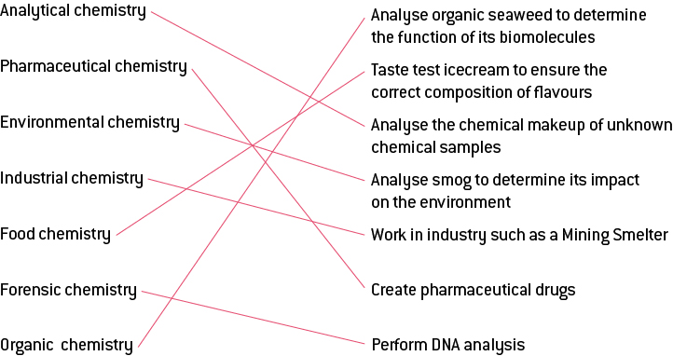

5.6 Science as a human endeavour: Physical and chemical changes are used to recycle household waste

Literacy support answers (pages 90–91)

Recycling

1 How many groups are plastics classified in to?

Plastics are classified in to seven main groups.

2 The steps for the mechanical/physical recycling of plastics, below, are out of order. Place a number next to each sentence to place the steps in the proper order.

|  |  |
| --- | --- |
| Step Number: | Description of the process: |
| 4 | Floating off the plastics according to their density. |
| 6 | Cooling the strands and cutting it into small pellets so that it can be reused for new products. |
| 5 | Extruding the plastic by heating it to a melting state and forcing it into long strands. |
| 1 | Cutting the large pieces of plastic using shears or saws. |
| 3 | Separating the contaminants in cyclone (centrifuge) separators. |
| 2 | Shredding the plastic into small flakes. |

3 The chemical recycling of plastics involves a lot of what?

Energy

4 How can metals be recycled?

They can be recycled by melting and reshaping the metal.

5 What is corrosion?

Corrosion is a reaction between a metal and air to produce a different chemical.

6 What is the difficulty with rusting?

It cannot be reversed.

7 Match the plastics symbol with its descriptor:

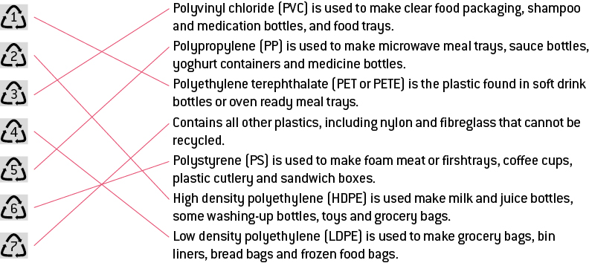

8 Which of the above plastics can be recycled by your curb-side rubbish collection? Which cannot?

In most areas 1, 2 and 3 can be recycled, but 4–7 cannot. Councils are developing way to recycle 4–7, though.

Word detective

9 Comic strip

Create a comic strip to encourage people to recycle. Use words such as: recycle, landfill, plastics and metals.

Answers will vary.